|  |
| --- |
| **Lockedme.com**  **(Application Screenshots)** |

**Version History:**

|  |  |
| --- | --- |
| Author | Mohammed Muthaq S |
| Purpose | Screenshots of the application |
| Date | 4th March 2022 |
| Version | 1.0 |

Contents

1.Main menu screen shot 3

2.Display All Files: 4

3. Add New Files 5

4. Delete a File: 6

5. Search File: 7

6. Exit: 8

# 1 .Main menu screen shot

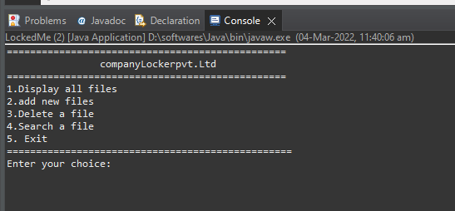

# 2.Display All Files:

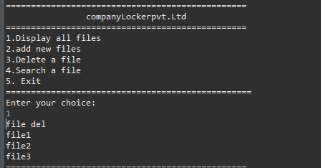

# 3. Add New Files

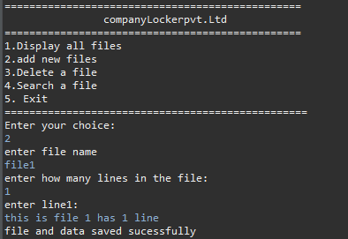

# 4. Delete a File:

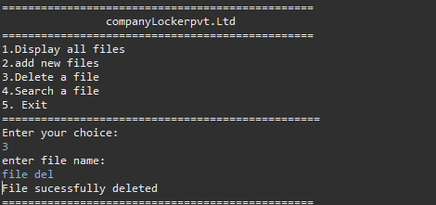

# 5. Search File:

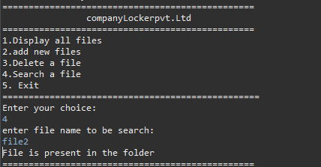

# 6. Exit:

